**PRACTICAL 6:**

**CONVERSION OF CELSIUS TO FAHRENHEIT**

* **Code (Same for all inputs)**

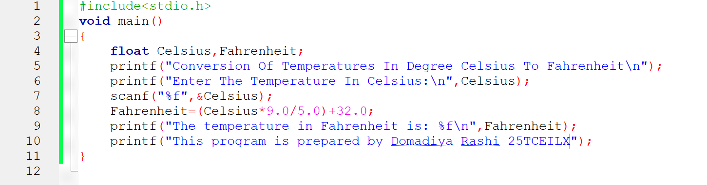

* **When The Temperature Is 00C:**

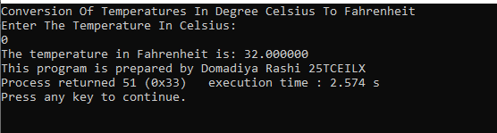

* **When The Temperature Is 1000C:**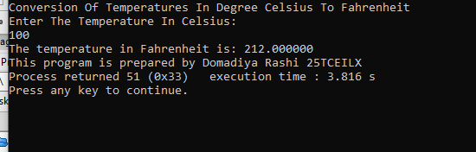
* **When The Temperature Is -400C:**

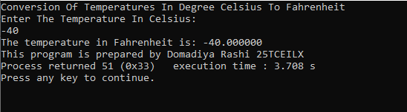

**THIS PRACTICAL IS PREPARED BY DOMADIYA RASHI 25TCEILX**